Exp. 5. Band Structure Simulation for Graphene and CNTs using NanoHub
Aim: To simulate the band structure of nanowire for various mat
Output:
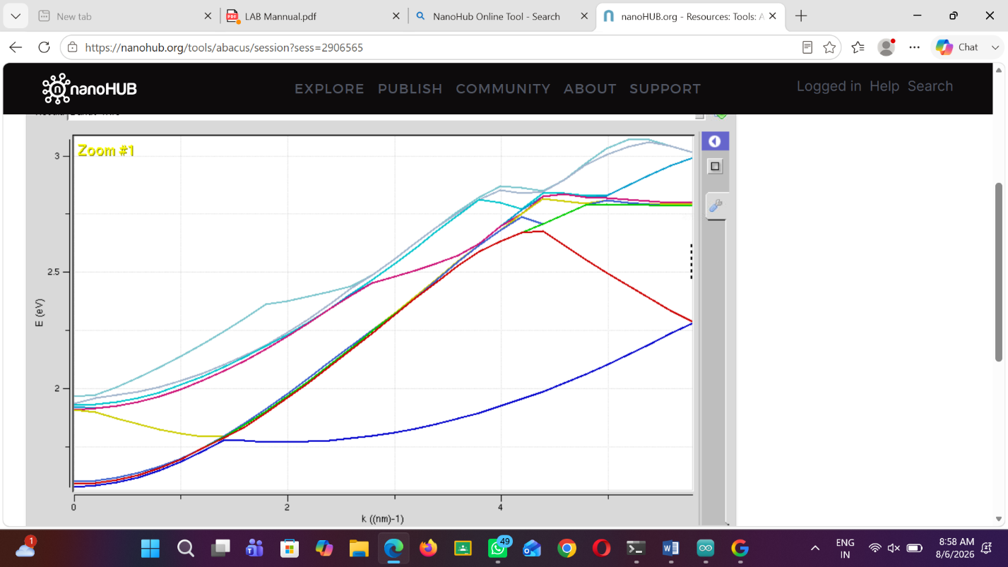
Case Study 1: Simulate the band-structure of InAs circular nanow
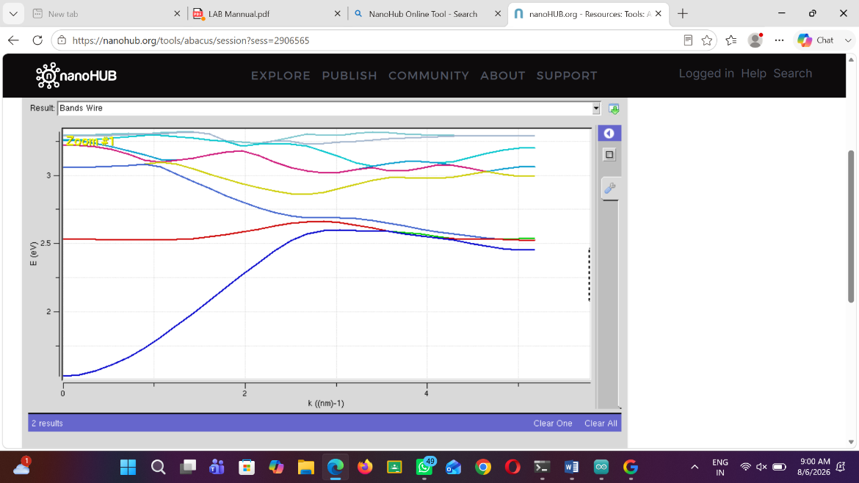

Case Study 2: Simulate the band-structure of AlGaAs circu
